1. Write a shell script whose single command line argument is a file. If you run the program with an ordinary file, the program displays the owner’s name and last update time for the file. If the program is run with more than one argument, it generates meaningful error messages.

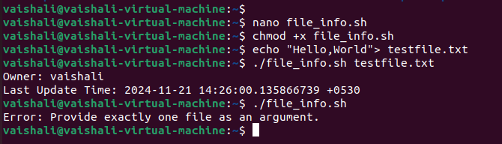

Save and exit (Steps after nano )

* Press Ctrl + O, then Enter to save.
* Press Ctrl + X to exit.

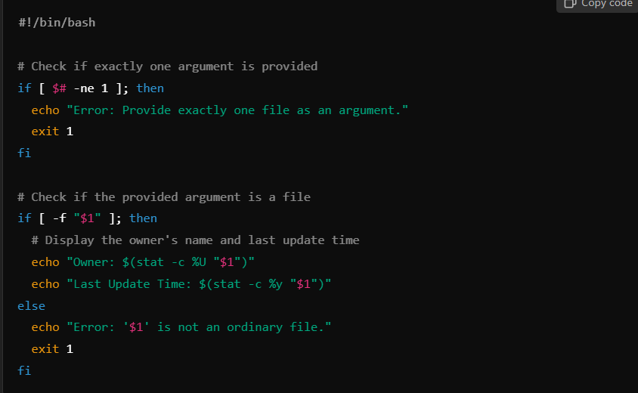

1. Write a shell script that accepts two directory names bar1 and bar2, and delete those files in bar2 whose contents are identical to their namesakes in bar1.

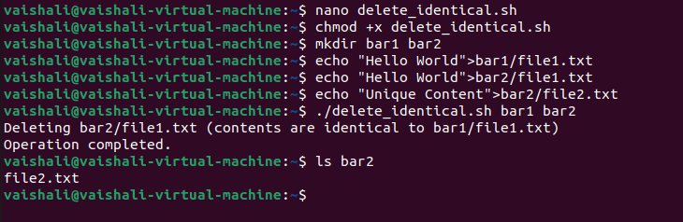

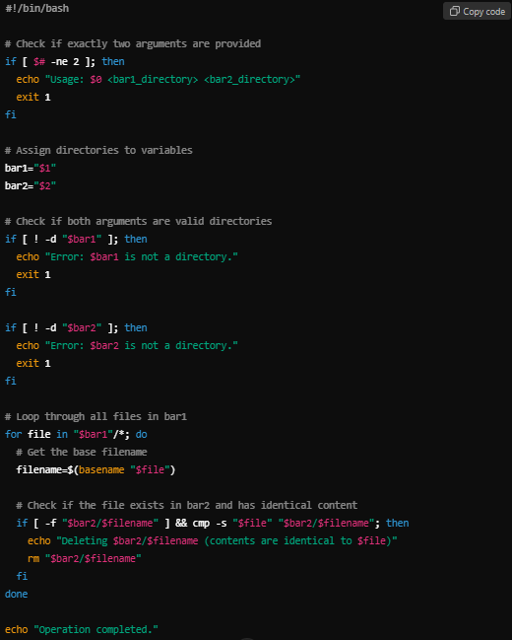

1. Write a script that reads a "password" from a user (it will not show when typed, but will get displayed after the carriage return is entered).

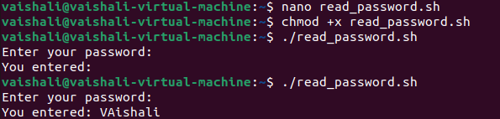

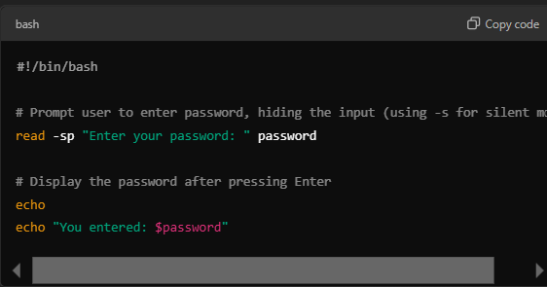

1. Write a shell script called whichdaemon.sh that checks if the httpd and init daemons are running on your system. If an httpd is running, the script should print a message like, "This machine is running a web server."

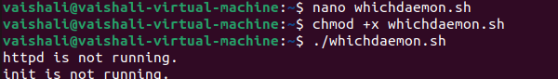

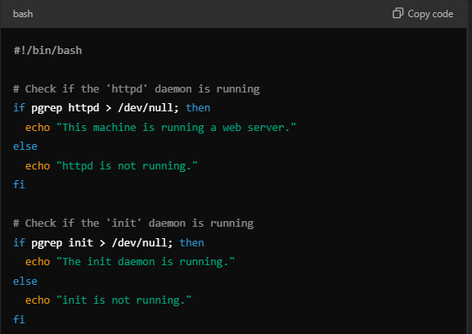

1. Write a script that simulates the ls –l command but prints only three columns of your choice.

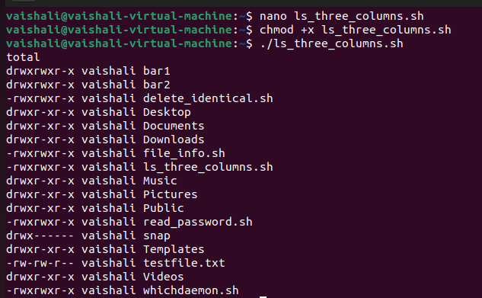

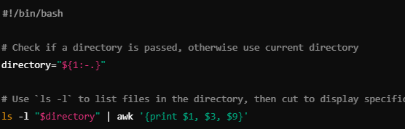

1. Write a shell script that, given a filename as the argument, deletes all even lines (lines 2,4,6…n) in the file.
2. Write a shell script that, given a filename as the argument, combines odd and even lines together. In other words, lines 1 and 2 become line 1, lines 3 and 4 become line 2 and so on.
3. Write a shell script named count, which takes a file name as its parameter and prints number of blank lines in it. Also display the lines containing ‘is’ as a whole word in it (or the only word).
4. Write a shell script that takes a variable number of directory names as arguments. If no arguments are entered the script should abort with an appropriate error message.

For each directory in the given list, the script should display the filename and the size of the directory (including hidden files) in the following format:

<Directory Name>: - bytes occupied

1. Write a script that takes exactly one argument, a directory name. If the number of arguments is more or less than one, print a usage message. If the argument is not a directory, print another message. For the given directory, print the five biggest files and the five files that were most recently modified.
2. Write a script that does the following:
   1. Display the name of the script being executed.
   2. Display the first, third and tenth argument given to the script.
   3. Display the total number of arguments passed to the script.
   4. If there were more than three positional parameters, use **shift** to move all the values 3 places to the left.
   5. Print all the values of the remaining arguments.
   6. Print the number of arguments.

Test with zero, one, three and over ten arguments.

1. Write a shell script that locates all the hard links of the argument file from the home directory. The filename provided as argument must exist in the current directory.
2. Write a shell script that takes an ordinary file as an argument and removes the file if its size is zero. Otherwise, the script displays file’s name, size, number of hard links, owner, and modify date. Your script must do appropriate error checking.
3. Write a script that would recognize if a word entered from the keyboard started with an upper or lower case character or a digit. The script would then output the word, followed by "upper case", "lower case", "digit", or "not upper, lower, or digit".
4. You are making a batch of beer. The beer has to stand in a warm place for 7 days and after that it has to stand in a cooler place for 2 weeks. You have a tendency to loose track of such mundane things so you want to write a small script that sends you a letter after 7 days telling you to move the beer and another letter 2 weeks after that that tells you that the beer is finished.

1. Write a shell script to convert file names from UPPERCASE to lowercase file names or vice versa.
2. Write script to determine whether given command line argument ($1) contains "*" symbol or not, if $1 does not contains "*" symbol add it to $1, otherwise show message "Symbol is not required".
3. Write a script to calculate factorial of a given number.

(b) Write a script that will print message “Hello World” in bold and blink effect, and in different colors like red, brown etc.

1. Write script to implement background process that will continually print current time (digital clock) in upper right corner of the screen, while user can do his/her normal job at $ prompt.
2. Write shell scripts which works similar to the following Linux commands:

**head tail**

Try to incorporate as many options as possible that are available with these Linux commands.

1. Write a script that asks the user to input a number and displays the squares of all numbers from 1 upto that number as follows:

1 Square=________

2 Square=________

:

n Square=________

(n is the number entered by the user)

1. Write a shell script, which takes a argument either R, W or X and displays the names of all the ordinary files for which the user has read, write and execute permissions, respectively. If no arguments are entered, then the script should display the message:

Enter Either R, W or X:

And accept the argument. If an invalid argument is given, the script should sound the system bell, display the following message, and exit.

INVALID ARGUMENT! CANNOT EXECUTE!

1. While executing a shell script either the LOGNAME or the UID is supplied at the command prompt. Write a shell script to find out at how many terminals has this user logged in.
2. Write a shell script for renaming each file in the directory such that it will have the current shell PID as an extension. The shell script should ensure that the directories do not get renamed.
3. Write a shell script, which receives any year from the Keyboard, and determine whether the year is a leap year or not. If no argument is supplied the current year should be assumed.
4. Write a shell script, which will automatically get executed, on logging in. This shell script should display the present working directory and report whether your friend whose logname is aa10 has currently logged in or not. If he has logged in then the shell script should send a message to his terminal suggesting a dinner tonight. If you do not have write permission to his terminal or if he hasn’t logged in then such a message should be mailed to him with a request to send confirmation about your dinner proposal.
5. Write a script asking the user to input some numbers. The script should stop asking for numbers when the number 0 is entered. The output should look like:
6. user: logon_name
7. Lowest number entered:
8. Highest number entered:
9. Difference between the two:
10. Product of the two:
11. A shell script receives even number of filenames. Suppose four filenames are supplied then the first file should get copied into second file, the third file should get copied into fourth file, and so on. If odd number of filenames are supplied then no copying should take place and an error message should be displayed.
12. Write a shell script, which displays a list of all files in the current directory to which you have read, write and execute permissions.
13. Write a script that would first verify if file "myfile" exists. If it does not, create it, then ask the user for confirmation to erase it...
14. Write a shell script, which receives two filenames as arguments. It should check whether the two file’s contents are same or not. If they are same then second file should be deleted.

### Write a shell script that adds an extension “.new” to all the files in a directory.

1. Write a shell script whose single command line argument is a file. If you run the program with an ordinary file, the program displays the owner’s name and last update time for the file. If the program is run with more than one argument, it generates meaningful error messages.

### 34. Write a shell script to print a number in reverse order. It should support the following requirements.

* The script should accept the input from the command line.
* If you don’t input any data, then display an error message to execute the script correctly.

### 35. How will you delete a file which has special characters in its file name? Write a shell script.

### 36. WAS  How can we perform numeric comparisons in Linux?

### 37. WAS How will you find the sum of all numbers in a file in Linux?

### 38. Write a shell script to delete the lines containing a word <dd> if it appears between the 5th and 7th position?

### 39. Write a shell script to find out the unique words in a file and also count the occurrence of each of these words. We can say that the file under consideration contains many lines, and each line has multiple words.

### 40. Write a shell script to get the total count of the word “Linux” in all the “.txt” files and also across files present in subdirectories.

1. Write a sed script/command, to perform the following task. Refer to the below mentioned database, db1, for performing the task.

-----------------------------------------------------------------------

Name of Friend DOB Hobby Phone #

-----------------------------------------------------------------------

V.K. Rajopadhey 5/12/73 Food, Music 98220-5678

5/22,Stree 4,

A'bad,MH, INDIA.

A.G. Gite 15/6/72 Computers, Book Reading 98220-3333

22, MIDC,

Mumbai,MH, INDIA.

M.M. Kale 2/1/71 Food, Drinks, Lifestyle 98220-6823

6/21,Silver Estate,

A'bad,MH, INDIA.

R.K. Joshi 9/10/70 Colletion of Old coins 98220-6877

Flat No.9, Pushpa Towers,

Pune,MH, INDIA.

N.K. Kulkarni 1/2/74 Computer Games 98220-9888

Sector 20, Padmavti,

Pune,MH, INDIA.

-------------------------------------------------------------------------

The task is as follows for db1 database file:

1) Find all occurrence of "A'bad" word replace it with "Aurangabad" word  
2) Expand MH state value to Maharastra  
3) Find all blank line and replace with actual line (i.e. ========)  
4) Insert e-mail address of each persons at the end of persons postal address. For each person e-mail ID is different

### 42. Write a shell script to print the count of files and subdirectories in the specified directory.

### 43. Write a shell script to print the reverse of an input number.

### 44. Write a shell script to reverse the list of strings and reverse each string further in the list.

### 45. Write a shell script to display the last updated file or the newest file in a directory?

**46.** Write a shell script, which takes a argument either R, W or X and displays the names of all the ordinary files for which the user has read, write and execute permissions, respectively. If no arguments are entered, then the script should display the message:

Enter Either R, W or X:

And accept the argument. If an invalid argument is given, the script should sound the system bell, display the following message, and exit.

INVALID ARGUMENT! CANNOT EXECUTE!

47. While executing a shell script either the LOGNAME or the UID is supplied at the command prompt. Write a shell script to find out at how many terminals has this user logged in.

48. Write a shell script for renaming each file in the directory such that it will have the current shell PID as an extension. The shell script should ensure that the directories do not get renamed.

### 49. Write a shell script to find out the unique words in a file and also count the occurrence of each of these words. We can say that the file under consideration contains many lines, and each line has multiple words.

### 50. Write a shell script to get the total count of the word “Linux” in all the “.txt” files and also across files present in subdirectories.

### 51. Write a shell script to validate password strength. Here are a few assumptions for the password string.

* Length  – minimum of 8 characters.
* Contain both alphabet and number.
* Include both the small and capital case letters.

If the password doesn’t comply with any of the above conditions, then the script should report it as a <Weak Password>.

### 52. Write a shell script to print the count of files and subdirectories in the specified directory.

**53.** Write script to determine whether given command line argument ($1) contains "*" symbol or not, if $1 does not contains "*" symbol add it to $1, otherwise show message "Symbol is not required".

**54.** Write a shell script that, given a filename as the argument, combines odd and even lines together. In other words, lines 1 and 2 become line 1, lines 3 and 4 become line 2 and so on.

55. Write a shell script named count, which takes a file name as its parameter and prints number of blank lines in it. Also display the lines containing ‘is’ as a whole word in it (or the only word).

56. Write a shell script that takes a variable number of directory names as arguments. If no arguments are entered the script should abort with an appropriate error message.

For each directory in the given list, the script should display the filename and the size of the directory (including hidden files) in the following format:

<Directory Name>: - bytes occupied

### 57. Write a shell script to validate password strength. Here are a few assumptions for the password string.

* Length  – minimum of 8 characters.
* Contain both alphabet and number.
* Include both the small and capital case letters.

If the password doesn’t comply with any of the above conditions, then the script should report it as a <Weak Password>.

58.. Write a shell script called whichdaemon.sh that checks if the httpd and init daemons are running on your system. If an httpd is running, the script should print a message like, "This machine is running a web server."

59. Write a shell script that takes an ordinary file as an argument and removes the file if its size is zero. Otherwise, the script displays file’s name, size, number of hard links, owner, and modify date. Your script must do appropriate error checking.

60. Write a script that would recognize if a word entered from the keyboard started with an upper or lower case character or a digit. The script would then output the word, followed by "upper case", "lower case", "digit", or "not upper, lower, or digit".